Intimacy

Mysterious

Erotic

Generosity

Envy

Vigour

Jealousy

Proud

Flamboyant

Expansive

Vibrant

Warmth

Passion

Love

Excitement

Jealousy

Rage

Cowardice

Joy

Aggression

Happiness

Anger

Confidence

Strawberries

Tranquility

Roses/poppies

Contentment

Calm

Colouring pencil

Liverpool FC

Blood

Umbrella

Yellow pages

Mind Map Alex Damon

Trees/woodland area

Hazard signs

Crushed green leaves

Northern lights

Cucumber

Sunflowers

Sunshine

Lemon

Blue lid of a plastic milk bottle

Little plastic sauce pan

Fresh cut grass

Spring

Apricot jam

Rain

Waves

Water, rivers, oceans, seas etc.

Oranges/Satsumas

Technology

Sky

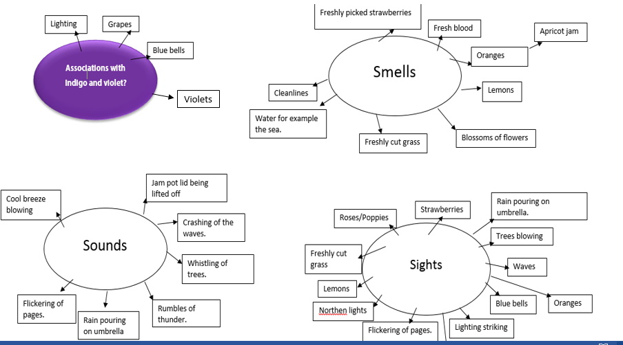

Grape Hyacinth

Purple Eggplant

Lilacs