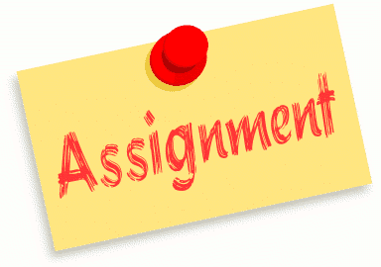
Graphic Design Analysis
5
8
GAME COVER
Assignment 1
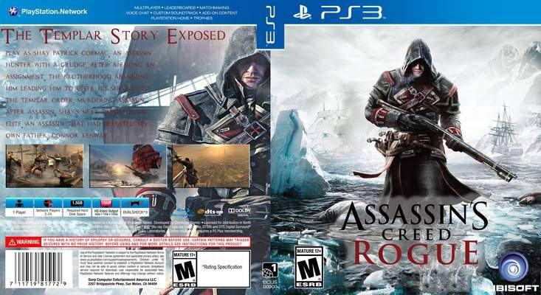

1

3

4
7
6
2

‘ASSASSINS CREED ROGUE’ ANAYALSIS
1
When I look at the genre, I straight away pick out this game has an adventure, action feel to it due to the ships and arctic ice features in the backdrop, which is located just behind the assassin. Next I pinpoint the style of the cover to old times/historical due to yet again the ships, and the weapons they use.

When you get playing on the game. You will discover all about the era it is set in, for instance the people around back, the weapons they use and the ships. As well as this you will pick out famous historical figures in the past such as ‘Charles Dickins’ for instance in other games like ‘Brotherhood’. ‘Brotherhood’ is another ‘Assains Creed’ game.
When you look at the back cover you see more indications that this is a historical game because if you look closely at the three mini game shots, there is a very much historical ship and a very past looking city. All of these indications that show the designer really wants to portray that era so it gives the game that historical side.
2
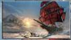

The colours of black and red used to portray the ‘Assassin’ give me an idea that that this character is a ‘dark’ character and red indicating evil and blood-letting.
Rogue describes the character as a rule breaker and maybe a loner,
As well as this I feel the designer has done well choose two complementary colours which work well together. The series is about a creed of ‘assassins’ who work together. Straight away you can tell calling the game ‘Rogue’ means protagonist is a rouge member of this creed therefore they put the ‘Rouge’ in big bold red letters to help communicate this message.

3
The target audience of this game is not for the younger generation gamers, due to the fact this game is all about, ‘Assassins’ and that will mean this game is going to be about violence because with Assassins there main job role involves the killing of people, the gun in the cover represents this. So when I cancel out the younger generation, I pick this game out to be a 15+ due to the appearance of the cover and I agree to this. Mostly all Assassin Creed games are 15+.

When you look at the marketing or selling of the game it is trying to franchise another game in the long historical story of ‘Assassins’ that venture through different eras. By previous experience in the game you can tell there is a lot of depth in this game due to the theme of the game which is the breaking of rules and breaking code and mostly, the most stand out point is becoming rogue.

You get quite a winter, cold mood because it is set in an out of the ordinary location with for example the ice lumps behind him portraying that. Winter colours such as teal for the water show that.
4

5
This game is very much stealth. Points of the cover I can refer this too is the hood up on the front cover so this means he is hiding his identity. As well as this his eyes have been blacked out giving us no idea who the ‘Assassin’ is, so that leaves us thinking as the audience.

When looking at composition it is composed as, fiction with historical facts and figures included, but this story is made up with circumstances that are true.

The biggest point of focus to me is the character but the main word ‘rogue’ is too as the character is very much rogue like. With for example the letter ‘R’ the designer has used the rasterizing effect to give the letter that sharpness.
6
Like I have stated before, this game cover uses a variety of winter feel colours such as teal for the water. Alongside that white shades for the snow features. The winter feel has been expanded by playing a part of making the text more effective as there is a frost effect as a background for the typography. This cold feeling supports the impression that the assasin is a character that has little emotion and regard for others. The remoteness of the location makes us feel that actions of the assasin are disconnected from society.
7

The red writing is used on the back to summarise all about the protagonist and the biggest evidence of this is the title ‘rogue’ and also on the back is a small part of his story. The red writing is not very clear to read on the back of the cover, but I do find it clever how the designer has shown the red font to recognise the main character.
8
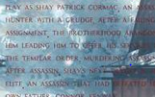

FILM COVER
‘BATMAN RETURNS’ Analysis
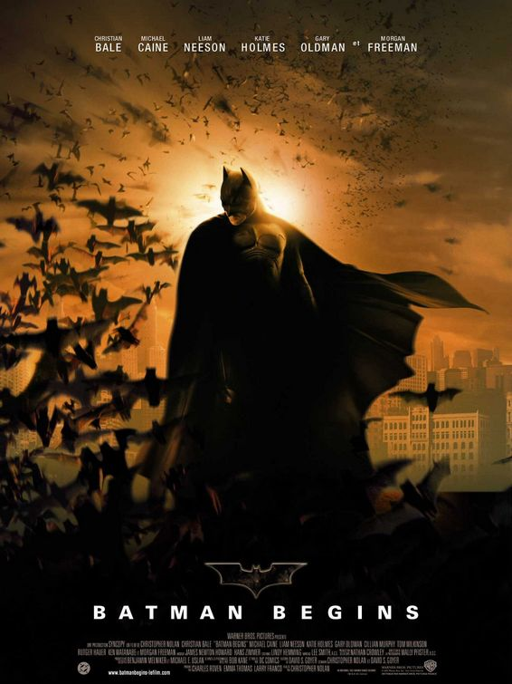
5

1
3

3
4
6
2

1
This film cover has a superhero theme to it, the way in which I know this is by the cape feature of the character. Capes an example of a feature which are associated with superheroes. This character has been designed to be in a black overlay colour to show his mysterious, evil, dark side. As well as this as the bats hover around him the wind effect they created has been shown by his cape flying around. The use of this colour and the array of bats flying around give the film that Halloween/ gothic theme.
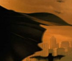

The depiction of Batman is an evolution of the original ‘DC Comics creation from the 1940’s, you can see that modern artist has taken influence from the original comic below. Where the dark flowing cape is portrayed. 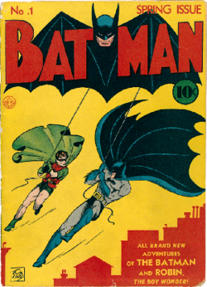

When analysing the title of the film, first impressions are there has not been much thought put into it as it is a very basic bold title but at the same time it is not very big so it is not so clear to pick out the title of this film. It left me searching. The designer has used a space each time he has wrote a letter which shows some creativity, in that it makes the reader read slowly. By using capital letters the impression of SHOUTING out adds to the impact, that the character is a strong figure, not to be ignored!
2

Going back to the use of colours, the hazy orange colour and black go well together so that means they are good complimentary colours. Yet again the Halloween theme has been portrayed. The character has evolved into a gothic feel from the original comic strip.

This film is just like my ‘Assassins Creed’ analysis because this film is franchising another film in the timeline of films Batman has produced. People who are superhero or Marvel fans will appeal to this
3
The biggest points of focus to me a few areas such as the Batman character, ‘the batman begins’ title, a small point of focus is the mini batman logo and finally the array of bats. This film case uses a variety of Halloween feel colours like I have stated before, such as black for the bats. Alongside that a hazy shadow from the sun on the city gives the Batman figure and the swarm of bats that extra stand out factor, so to me it seems the spotlight is on them. Batman clearly models himself on the bat, its behaviours and plays on the emotions and attitudes that people have towards them. We feel wary and even scared of them.
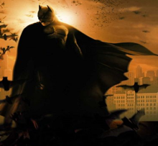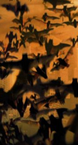

4
Going back to the genre of the film I see action has been portrayed very well because I get the impression the hazy orange backdrop may show smoke from example a burning building mixing in with the hazy weather and as a superhero it’s Batman’s job to save the day. This ties in with composition because the film has been composed as fantasy as you would not get a superhero saving you each day from every casualty which occurs.
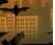
5
This game is very much stealth just like ‘Assassins’. Points of the cover I can refer this too is the mask so this means he is hiding his identity. As well as this his eyes have been blacked out giving us no idea who ‘Batman’ is, so that leaves us thinking as the audience.
6
When the mini batman typography was created it may be a film logo but it could well be a car company logo too as it has that metallic feel to it. I say magnetic because there is some kind of magnetic outline around the text.
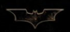

COMPARRISON
WEBSITE
+
FILM COVER
+
GAME COVER

Both film and game covers have action features included but comparing that to the ‘FedEx’ website there is no link or relation to Batman or Assassins Creed whatsoever. Due to the fact this site has more seriousness to it as it is a real life business.
However the common ground for FedEx and Batman is that the logos and name are easily recognisable and universally understood to what they represent in their field. Assassin Creed on the other hand is known to a smaller community, mainly gamers. However Sony, PlayStation and PS3 would be more widely recognised.
Going back to Assains Creed and Batman, both may have an action feel to it but there is also dark, adventure elements which pop up. When looking at difference again ruling out the website, Assassins Creed is all about the killing of people, as opposed to Batman where he saves his people from troublesome times. When looking at both covers, I would straight away say these have a common ‘killing’ theme. I say this due to their dark appearance. Both portray mystery and hidden identity.

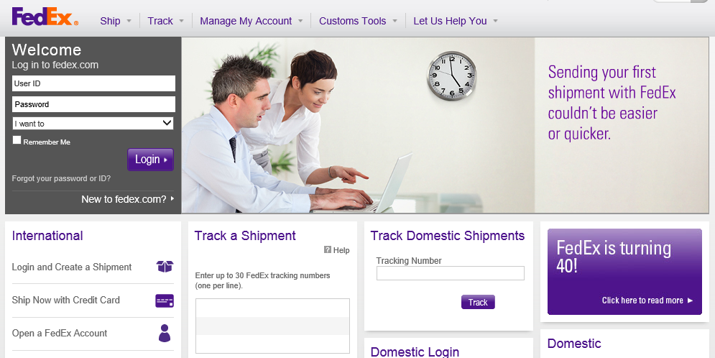
WEBSITE
11
WEBSITE ANAYLSIS FedEx
2
5
4
3

Straight away my mind went to the design and to me in a very clear way the website has a very simple design with a blank, empty appearance. It seems to be a basic IT Level one student could make better website. As well as this I have a change of mood to a dull feel.
As FedEx is a global brand this may help to portray itself across all countries, cultures and languages.

The site layout is not the only basic factor, another is the ‘FedEx’ logo. It is a very small looking logo and that gives me the impression it is a lost looking feature. Throughout the whole designing of the site I get an indication that the designer of this site has just given up and thought it would be best to put features just anywhere they can find. Another indicator to show this is the limited amounts of colour shown. I refer FedEx normally with orange and dark blue as seen on their delivery vans. I get the impression I am on the ‘Dorothy House’ website.
Different services within ‘FedEx’ have different colour combinations to portray these services.
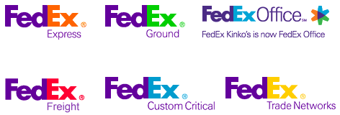
1
Not the site itself but with the logo of the business, some people wouldn’t be able to pick it out but in-between the letters of e and x there is an arrow pointing right. This is very much a ghostly feature.
2
‘Basic’ is a common theme and style of this website. This time it is the drop down buttons to navigate to certain pages. The content underneath these may not be basic but they still aren’t that great as this information is way too clustered.
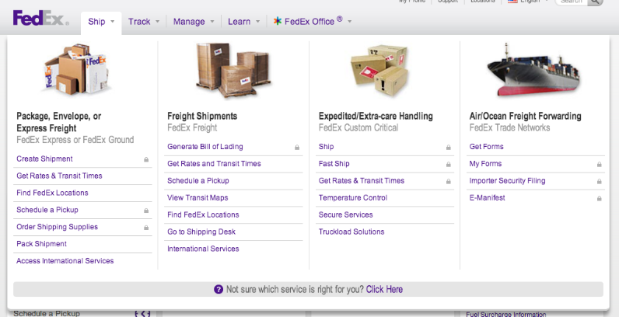
3
Images play an important part in website design I feel but when referring to this site it goes either way, there are good sides and bad points. Good because the little images on the left hand side towards the bottom let me have more of a clear understanding what certain words relating to FedEx mean. Such as shipment. Bad is in my opinion I think the images on the slideshow up top are too stretched out, that just shows another rushed part to the designing of the site, as well as this the image up top doesn’t exactly portray to me what FedEx does, so for instance when I see the picture shown I get the impression this site is about IT support as the woman character is showing the male character what to do on his laptop.

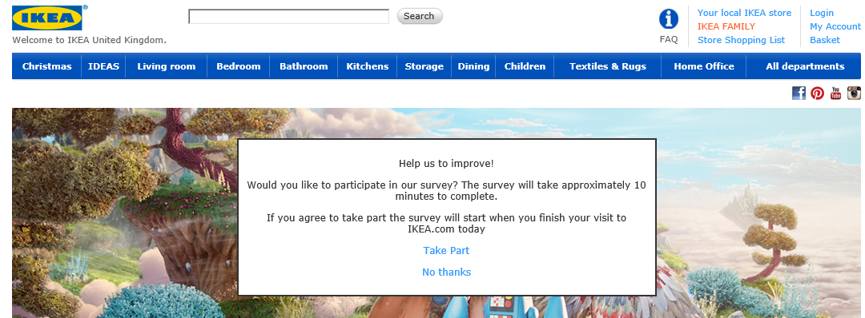
This website has a very similar feel to the ‘Ikea’ website as it follows that simplicity design with for example yet another small logo leaving me hard to pick out who the business are.

‘FedEx’ is a parcel delivery company, so people who want their parcel delivered will go to ‘FedEx’. This shows who the target audience is.
4
The purple writing used to portray different site features such as the sub headings is a very basic font for me to read, but I do find it gives me yet again a very dull feel and I become switched off of the site. When I look at the lettering of the advert next to the image and the advert below this, I wouldn’t be able to pick out these are adverts because they don’t have that big screaming advert feel to it.

5
Throughout this whole site there is only two buttons, these are ‘Login’ and also there is a button made to portray an advert they are advertising. When thinking about the design again, to me it looks again a very basic level 1 IT student’s work because it seems to me all they have done is typed in some text to create the logo, changed the fill to purple and made into ‘inner bevel’. To me I get the ‘I cannot be bothered feel’ and that the designer thinks it is a tick in the box job. Maybe the buttons should have had a ‘FedEx’ logo feel to it

