Different pioneers notes…

Lumiere Brothers
- Invented the cinematograph.
- This device is able to capture and project moving images.
- The first private screening regarding a projected motion picture took place in a Paris café, in 1895.
- It showed scenes where there was men leaving the factory and a train arriving into a station.
- Was the first film which was projected onto a wall for a room sized audience.
- Were the ones who invented the film cameras.
- Used static shots.
- State no real editing just recordings.

George Melies (professional magician)
- Is one of the first editors in film.
- Directed 531 films from the year 1896 to 1913.
- Films had a duration time of 1 to 40 minutes.
- Magic shows were the theme of the first edited films to be shown for example in “The one man band”. He featured in this film.
- Demonstrated editing techniques like jump cuts etc to create illusion.
- By having experience in skills such as editing and able to add in special effects techniques would be for the benefit of making “A trip to the moon”.
- “A trip to the moon” was the first sci-fi film and a really popular film in early cinema.
- Made for spectacle but not for good storytelling.
- Put in special effects and introduced cutting.

Edwin S Porter
- Used parallel editing to show two scenes.
- These two scenes would be shown in two different geographical locations, whilst going on at the same time.
- Tension would be created by this as well as providing to the audience a voyeuristic point of view, enabling them to see both scenes. Porter used this in his films.
- Film examples where this is applied were, “The great train robbery” and “Life of an American fireman”.
- Able to cut between two clips for the benefit of being able to have two parts happen all at the same time.
- Didn’t use the technique to its full potential.
- George Albert Smith was similar a pioneer. He made “A kiss in the tunnel”.
- There would be shots of a train entering and exiting a tunnel.
- This film would provide a geographical location feel, through editing.
- The editing were basic.
- Link into the creation of space by editing.

DW Griffith
- Created modern editing techniques which are still in use today.
- Would be able to cut between shot types.
- Wide shots were used to portray a whole set.
- Close ups were used to emphasise emotion, for example where eyes look at certain parts of a scene and ignore the other parts which are going on.
- Dissolves were to portray the passage of time.
- All these editing techniques and others to produce the film the Klansman. Renamed “Birth of a nation”.
- One of the first modern style.
- Contains lots of pioneering editing techniques and good storytelling.
- Contains historians being racist and mentions about the Klu Klux Klan as heroes at the south.
- Next film was called “Tolerance” was massive and was about a plea for tolerance.
- Features four different stories in different centuries and locations. These all tie together with tolerance. Link to time and space.
- They cut between apart from having no other relation between each other stories.
- Made shots ‘discrete’ for having a role in sections of scenes.
- Scenes would become livelier to watch as a viewer.

Russian Cinema
- Developed the art of film making in 1917.
- New techniques began to be practised for the benefit of being part of the making of film.
Russian montage editing.
- Film stock was tricky to find in Russia at this time period (after Russian revolution.)
- With limitations on film stock and limitations of what they could find meant not very long films were shot cutting together different parts.
- This was for the benefit of making a general meaning.
- Within the world’s first film school, Moscow Russia, this technique was taught.
- It was taught in the 20s as well as the 30s.

Lev Kuleshov
- Kuleshov experimented with editing to convey different meanings.
- Discovered “the Kuleshov effect” whilst experimenting.
- This is where you cut among ‘shot a’ and ‘shot b’, resulting in a much greater meaning.
- Sequence of shots were bolstered up, as he added more meaning to them. Before putting the shots together.
- For instance with only one shot of an expressionless man in to cut with bowl of soup makes the audience think he is hungry. But if the principle is cutting the same shot of the expressionless man and providing a coffin that will trigger the audience to think he is sad.
- This technique was put in place to produce great effect meaning for the benefit of communist propaganda film
- For example Sergei Eisenstein’s “Battleship Potemkin” having a release year of 1925.

Eisenstein

- Eisenstein thought that the connection between otherwise unrelated footage would be able to lead better emotion and ideas. This would be done within the audience.
- Was good to use for communist propaganda.
- He made and enforced in a montage which made to be powerful resulting in a film to have meaning.
- Took the work of Griffith and Kuleshov.
La Nouvelle & Vogue (The New French Wave)
- Were labelled as the rule breakers in editing.
- They had a part in making for example “jump cuts”.
- Rules they broke were the “180 degrees” rule.
- Created fresh new editing styles.

Developments in Editing Technology Notes
Moviola
- Was the first editing machine and was created in America.
- Made editing easier and more standardized.
- Created by Iwan Serruier in 1924.
- It is a vertical machine enabling editors to go to a film and play it which would be displayed on a small screen.
- Decisions on cutting would go on whilst the film is playing.
- Popular within their day. (1924)
- Used in World War two for journalists to cut together newsreels.
- At this time sound was new.
- A film made by a Moviola was the “The Jazz Singer”.
- It is a very loud machine.
- It has limitations on functionality. (link in linear editing)

Steamback Flatbed editor
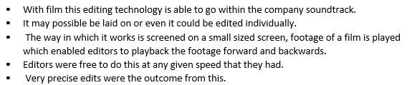
- Replaced the Moviola because of its limits on functionality.

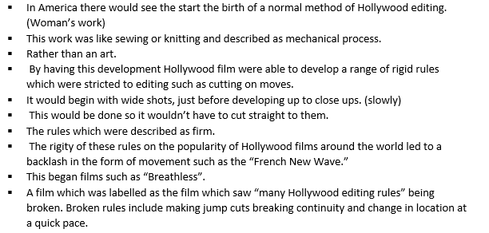

Video editing
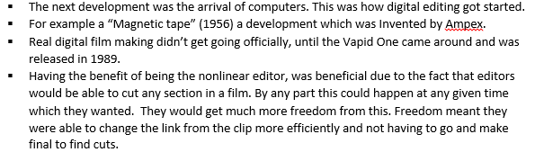
Digital editing
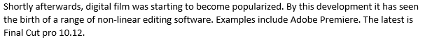

Benefits of digital editing...

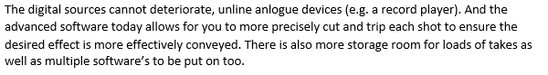

Editing definition

Time/Space and Rhythm
