‘7 November 2015’
Objective for today: (The collecting of the resources required for my project)

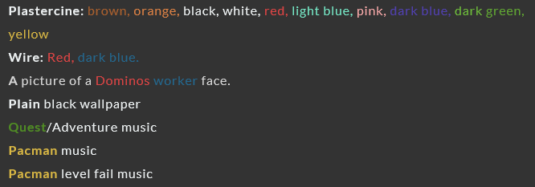
A LIST OF RESOURCES NEEDED

Disguising which resources I can get from ‘Devizes’ and which resources I can’t get.
With first actions towards this project, I firstly looked down on my list of resources which are required for my animation and spilt them into categories. The categories were as follows, resources which I am able to shop for, picture resources and sound track resources.
Resources which I am able to shop for category
Plastercine
Wire
To start, I can easily pick out that I am able to go to the ‘Autopart Centre’ in Devizes to collect the red and dark blue wire. This shop is ideal because it is very much like a mechanical/electrical shop so it was bound to have it in there and I was right. The final resource in this category was the need of some certain colours of plastercine to create features such as the ‘ghosts’. For a moment I had to think about this before in a flicker of a moment, I remembered my tutor said he would be able to supply to us a packet of all the plastercine colours, this resulted in me not having to go out and buy some myself. This made me happy as I can save money.
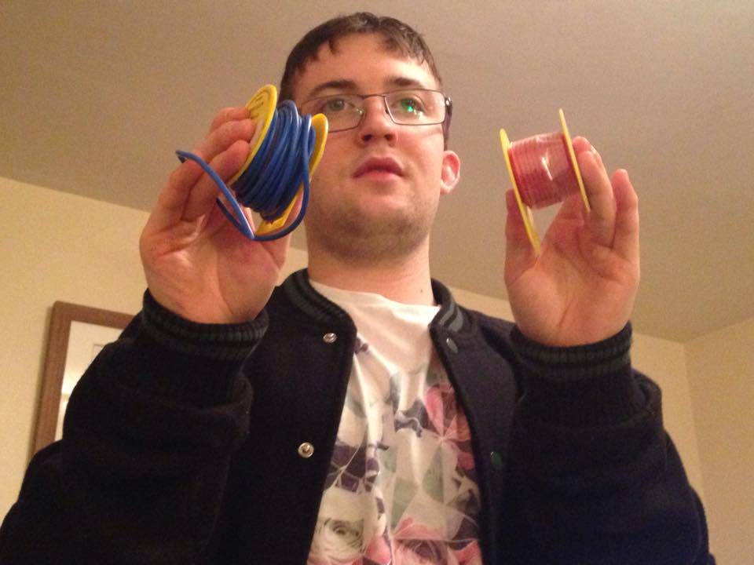
Me showing off the red and blue ‘wire’ resource after a good day shopping.

Picture resources
A picture of a Domino’s worker face
Plain black wallpaper

When looking at the next two categories, there is no involvement in me buying anything, as it was the case of me going onto the web and as a search type in a ‘Domino’s worker’ and a ‘plain black wallpaper’. Once I found myself the best suitable picture it was a case of printing it out and cutting out with scissors the unrelated parts.

Sound track resources
Quest adventure music
Pacman music
Pacman level fail music

Just like the ‘picture resources’ category, this was a category I wasn’t just able to go out and buy it. This may be resources which I need to collect for my animation but at this current moment in time, I am not able to download the soundtracks due to the fact that we haven’t even started animating or creating the features for our animation yet. The soundtracks will be put in place when we start the editing process.

’13 November 2015’
Objective for today: (The making of all the features such as the pizzas)

Groups and ideas
It was our second session towards the completion of our animation project and to kick today off, it was a case to decide upon our groups. With swift decisions, I was in a group of two with Aaron comparing to everyone else’s groups of three. With no complaints from either team, it was time to move onto having a discussion with our partner about each of our main, best idea. With some good ideas coming across from Aaron which I liked very much, we agreed come ten minutes that my idea would be best suited due to the fact it was simple, achievable and imaginative. Aaron idea was slightly more the opposite. This is the reason behind why we have come to a decision to take my idea forward.
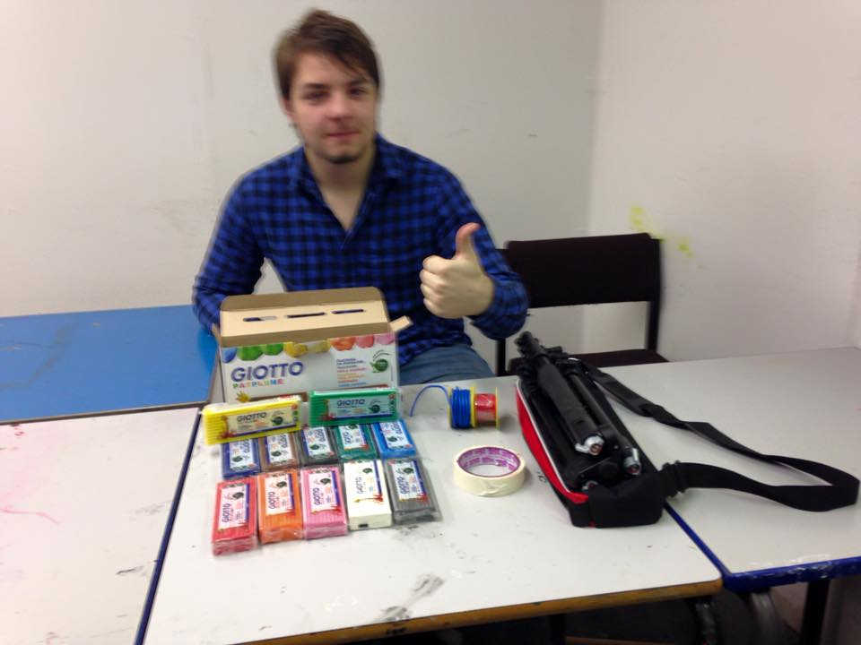 My partner Aaron ready to get stuck in with the creating of the features today.

Location for the day and preparation for creating features
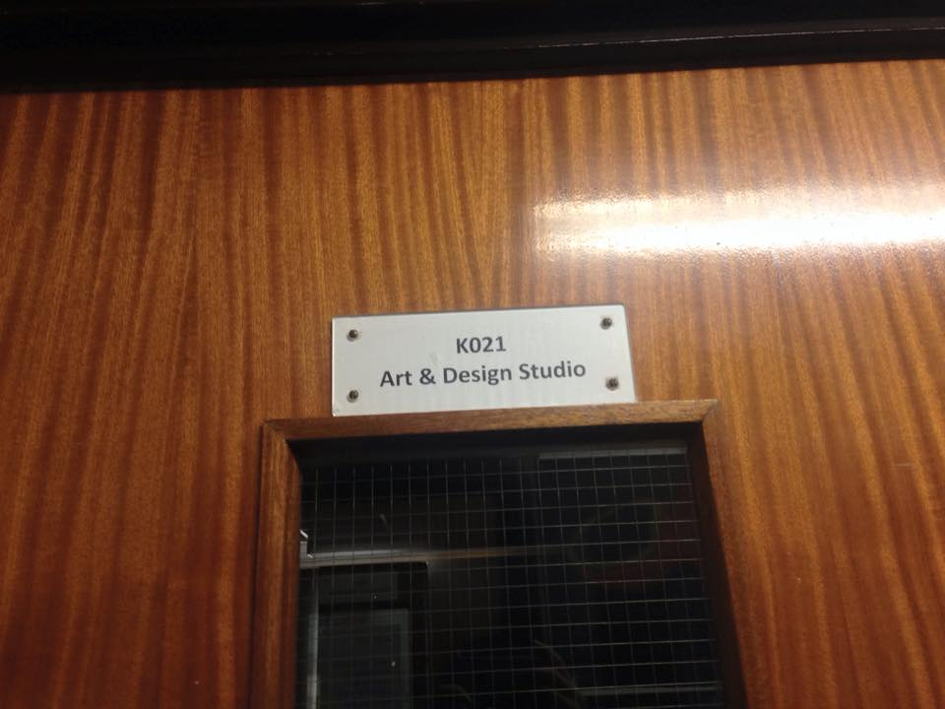
Everything above was done at such a quick pace meaning we were able to head down to our room for the day, (K021) quicker than expected. K021 is a spare ‘art and design studio’. Once we were all together with our own separate resources in hand, it was time to set up on tables. Preparation for me and Aaron was simple as we had to get the plastercine off our tutor, as well as this the tripod and camera. The rest of the preparation was our own resources, the red and blue wire. Where the scellotape was concerned it was already on the table for us.

The creation of our pizzas and Pacman.
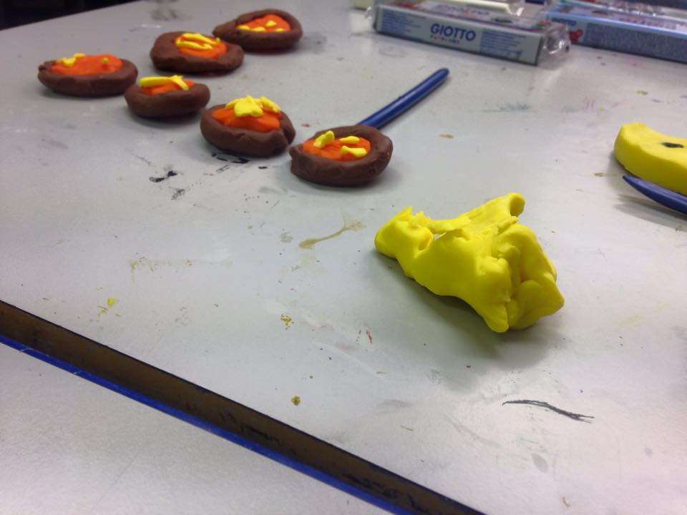
After a simple start and anxiously waiting for this moment, we were ready!!! To start we went with the part that we established that would take the longest to make, it was the making of the 12 pizzas and the one burnt pizza. In parts of the discussion we identified, I am quite a slow worker so it would best for me to crack on with the pizzas, whilst Aaron makes a Pacman figure. The predicting of me being slow was proved as it took me a whole hour and a half creating every one. In my opinion I may have been slow but I took my time with tasks at hand such as, rolling out the ‘brown’ plastercine, making it into a circular shape for the crust and making squashed bits of ‘orange’ plastercine to make up the pizza base. During my time of creating, Aaron suggested to me a brilliant change of idea for the ‘Domino’s worker Pacman’, “why don’t we change the Domino’s worker, to a Pacman figure to make it more realistic.” I couldn’t agree more with him, so as I was finishing up, he undertook his idea by carving parts out with a plastic knife to make yet another Pacman.

Some of my ‘pizza’ creations on the left hand side.
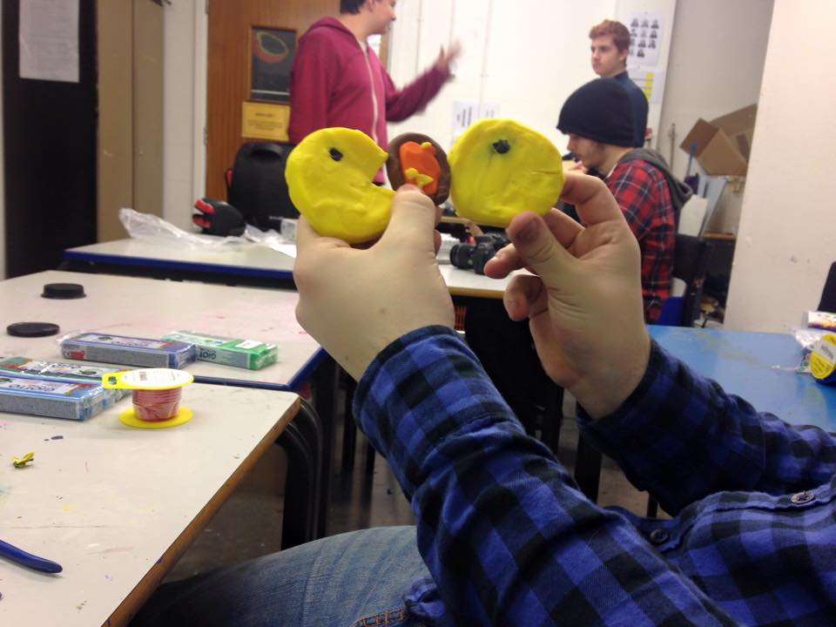
Aaron showing off his two ‘Pacman’ creations.

The extra toppings to the pizza
The ideas between me and Aaron were now flowing just like a ‘river!’ this time it was my input. The idea came as I looked at the array of pizzas and in my opinion they were looking very dull like with not much activity. So to add a bit of excitement to proceedings, I suggested we made some different toppings out of the plastercine, such as ham, lettuce, cheese olives and tomatoes. 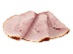For example with the tomatoes we made tiny red balls. We were able to do this together, as we both got are early tasks done. I did half of the toppings and Aaron did the other half. I did lettuce and tomatoes, Aaron did cheese, ham and olives. Once these toppings were done we placed them on top of the pizzas.
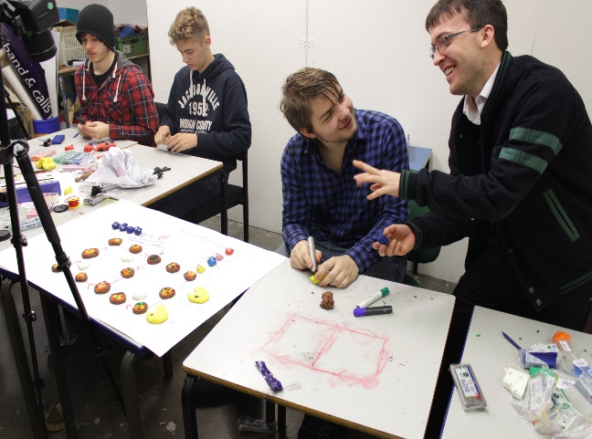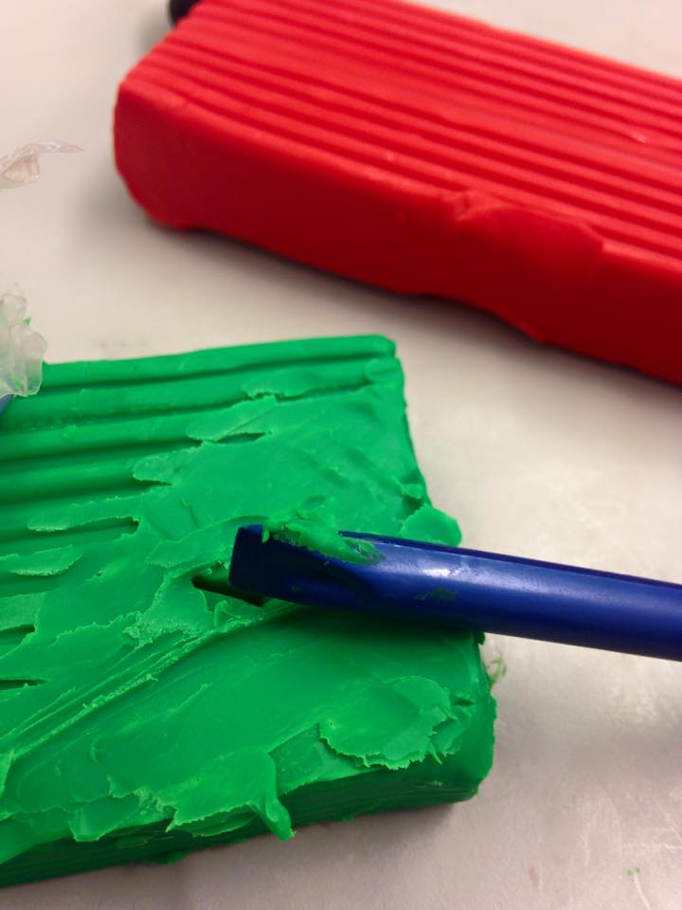
Me suggesting the different ‘topping’ idea forward to Aaron.
Me carving out some little lettuce pieces.

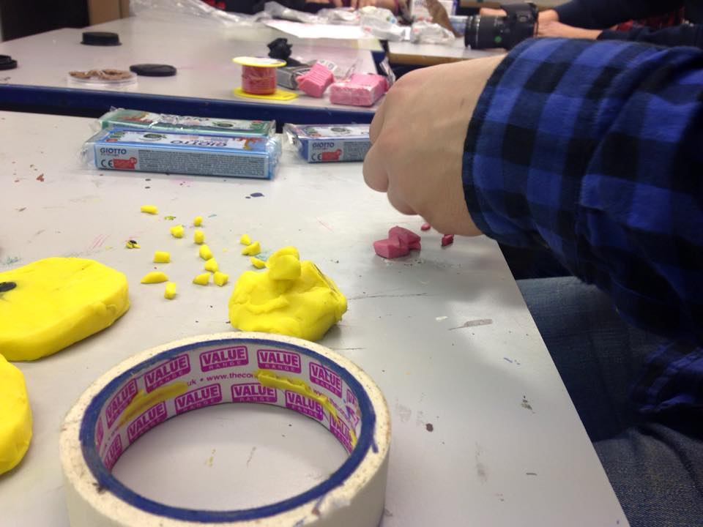
Pre made cheese on the table whilst Aaron moves on to prepare the ham.

The making of the Domino’s white circles
Before you knew it, it was break time. In our break we had been given an official given time of 15 minutes, so in that time Aaron went off to get a snack and drink and it was certainly deserved after his good efforts in the first half of the morning. As he was enduring his break, I stayed on in the classroom showing dedication, to get another part done and I did that successfully within the 15 minute break. The task I did was a simple one which involved me rolling out three flat white circles to make the three circles in the official ‘Dominos’ logo. By doing another feature was on the completed list.
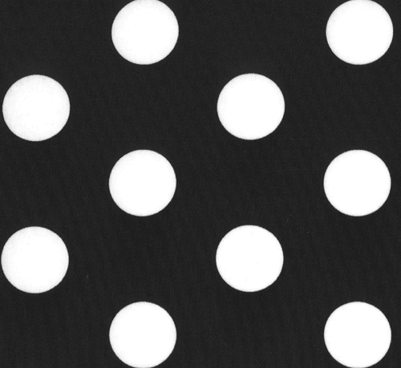

A combined effort in making the ‘Ghosts’.
After break, we were back together producing another half and half effort. As part of the real life ‘Pacman’ game there are ghosts, (red, gold, light blue and pink) and for my animation I want to portray them, as I feel they play an important role. As there are four ghosts, I and Aaron did two ghosts each. I was left to do gold and light blue. Once again Aaron was on it with speed and ease, whereas me I was slow again but I took pride of my efforts as I took the time to make them look so alike. Tasks involved making little balls for the body, little white circles for the eyes, tiny black circles for the pupils and little balls for the three tentacles. After thinking my ghosts were good, Aaron saw in the flicker of his eyes better looking ghosts than ours. I was heartbroken! After thinking for at least three minutes, I had second thoughts and did agree it would be best to ask if we could borrow Alayna’s and Darius’s ghosts because they were so similar to the real ones. Before we did this we got the confirmation if it was ok from our tutor.
Once they both accepted, I wanted to then go on and make an extra five ghosts. These ghosts will all be dark blue. Four of them are for when the Pacman hits the burnt pizza which then triggers a change of colour and as the other is concerned it is for the ‘evil’ ghost used to kill Pacman. The same process of creating these ghosts were the same as before, but just a change of colour in plastercine (e.g red to dark blue). I was left with this job as Aaron got on with other tasks, this left me happy and confident. The confidence came from the making of the two previous ghosts, I felt like an expert ghost maker now!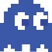
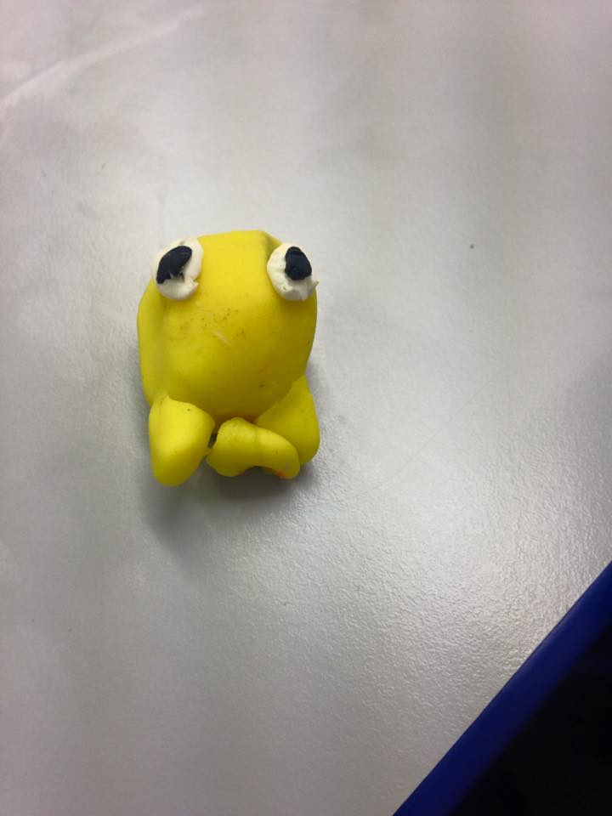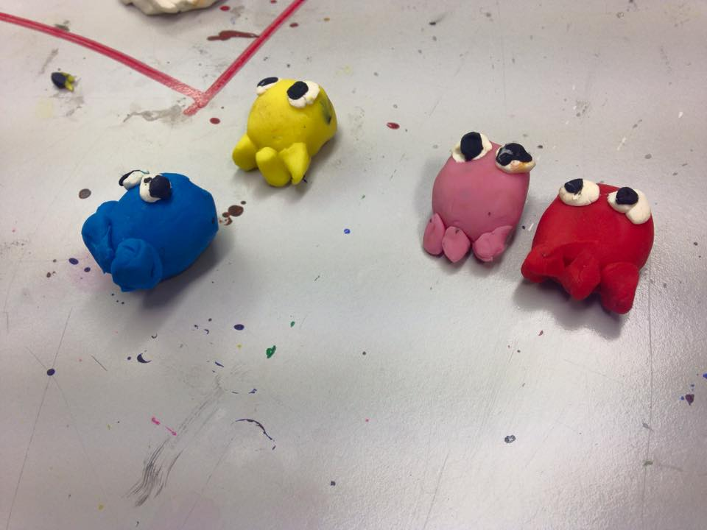
My ‘gold’ looking ghost.
After creating half and half ghosts each, here is mien and Aaron’s put together.

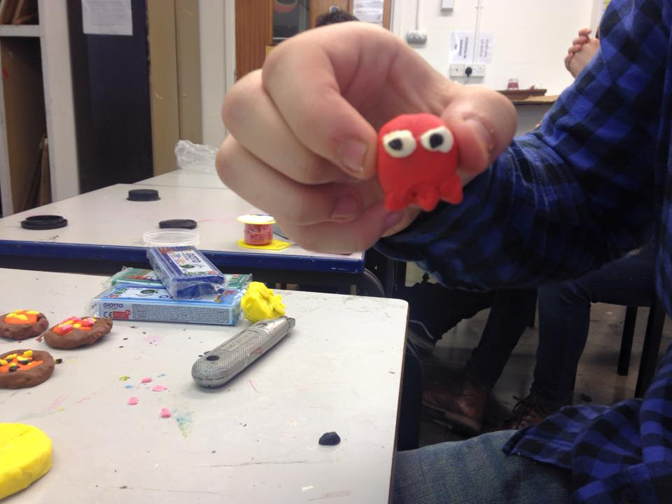
Aaron showing off his ‘well made’ red ghost.

A rough sketch of the plan
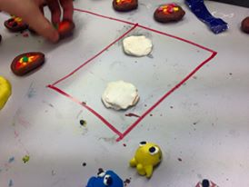
As I continue on from the end of the last paragraph, where Aaron got on with other tasks, his next task fell to mapping out the plan, a task I would have never thought we would get to do in today’s session. By getting to this stage it is a clear indication that together, we are well ahead of schedule which I am happy about. Back to the task at hand, Aaron got both a red and green marker pen and simply drew out the formation of how the animation will work by annotating it with annotated arrows. Red was to show the Pacman’s trail and green for the ghosts trail on the ‘Dominos’ logo. I thank Aaron for doing that all on his own during the time of me still ploughing through the making of the ‘dark blue’ ghosts. I had a little contribution towards this, as right at the end I helped put all the features we have made so far on the plan to have a rough idea what it would look like.

Starting to put some of the features we have created so far on the plan.

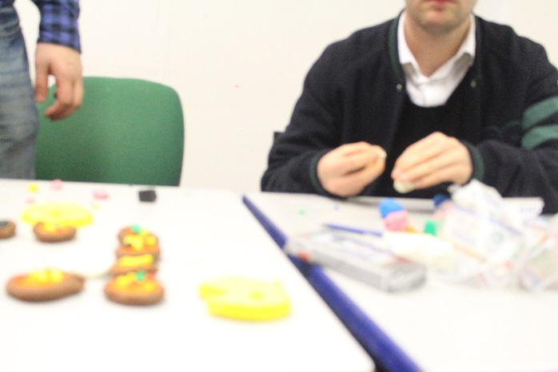

A picture of me as Aaron sorts the plan out, I continue making the ‘dark blue’ ghosts at a slow, delicate pace.

The making of the ‘Lives’ title
For a moment when we got the last task done, I got the impression that we had finished everything off and all up to a high standard. But then I just remembered another part which has to be added to the features. It was the ‘Lives’ title! I was thinking it would make sense as we do have a Pacman already made. We made this title out of the plastercine as that way it maintains the use of plastercine throughout. Aaron straight away volunteered to make it, and I handed it to him because he is so good at carving out plastercine with a plastic knife, to make it into big chunky letters. We used dark green to have a bit more variety.
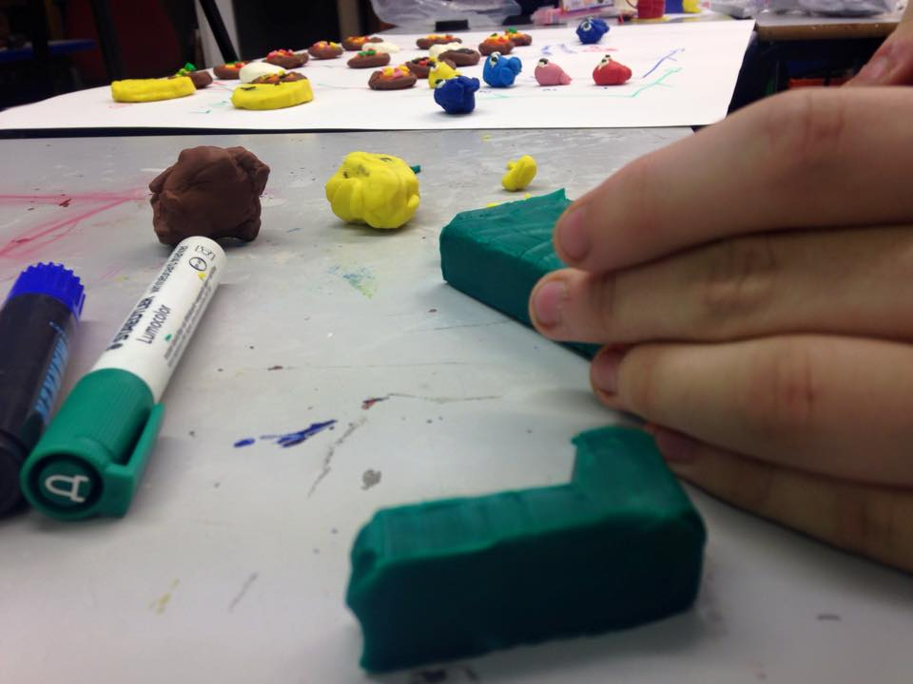The process of the letters for the ‘Lives’ title being made by Aaron.

From wire to plastercine for the outline
As the closing stages of the creating of the features nearly comes to an end, me and Aaron had at least our sixth in depth conversation about possibly changing parts around, but this suggestion from Aaron was a certain change we wanted to make. As a replacement for the red and blue wire, we were thinking the wire would lead to some problems such as it will not be big enough to see as an outline, it is only a small piece of wire. As a replacement we used the remainder of our red and blue plastercine. The good part with using plastercine we can make the outline as big or small as we want. So again like in previous tasks we linked together and did one each, Aaron did red for the top half of the logo, and I did blue for the bottom half of the logo. In quick succession of creating these different lengths it was time to place them on the plan alongside the other features ready for the animating next week.
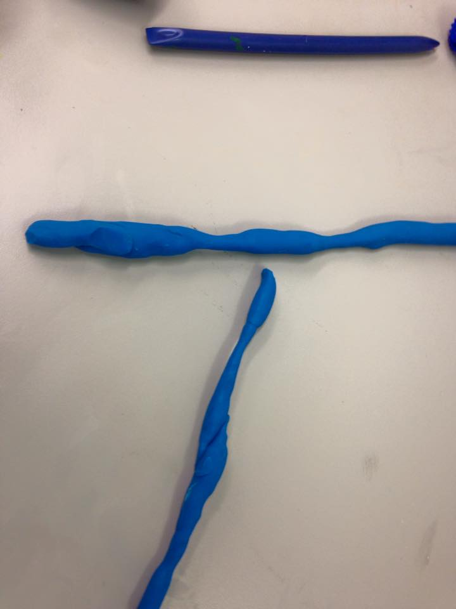
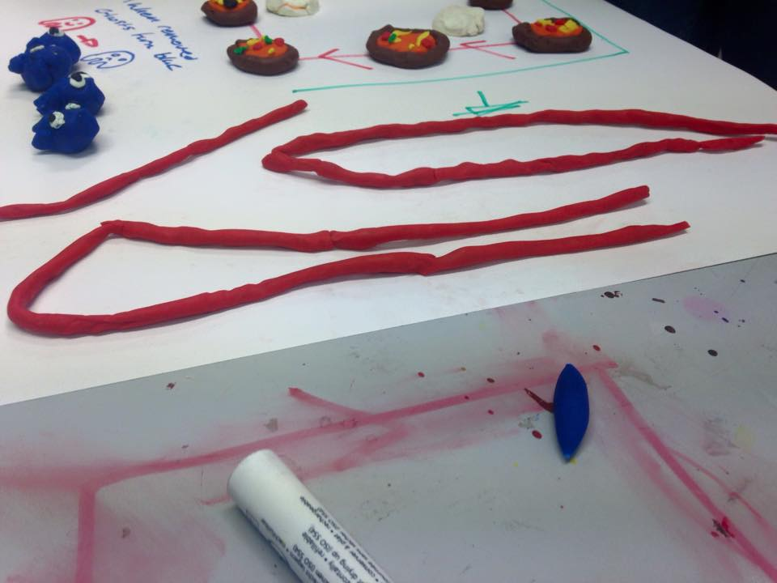
My blue plastercine lines for the outline
Aarons red plastercine lines for the outline.

The concluding feature
With the end of the day in sight, Aaron sadly got side tracked and went off to another group to help out, so that left me in a position where I think everything is done, but once again like the ‘lives’ title, I just remembered there is one final part and it is a very important part to our features it felt so embarrassing to say I forgot about it! It was the lettering of ‘Domino’s Pizza!’ It was a huge school boy error! So as Aaron helped out another group, I went on to show independence by creating simple letters using the last little bit of white plastercine, these letters of mien were less complicated and chunkier than Aaron’s. Thankfully I got these letters done in the neck of time, just before time to pack up. Judging from today, I can go home happy now due to fact I have completed today’s objectives with partner Aaron and we can officially say together we are ready to animate in the ‘green screen room’ next Friday!
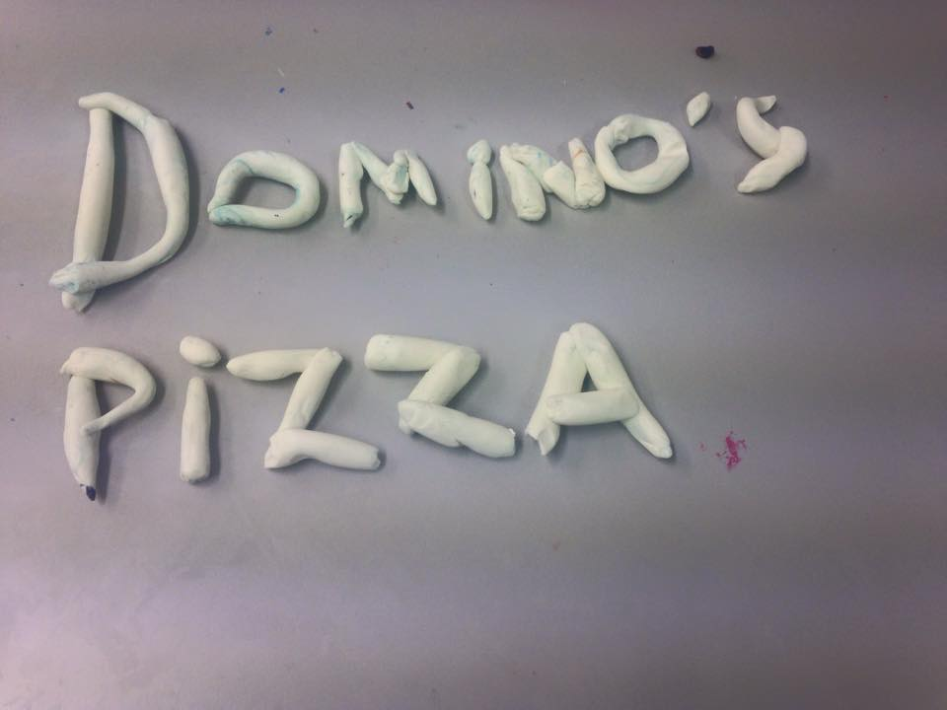
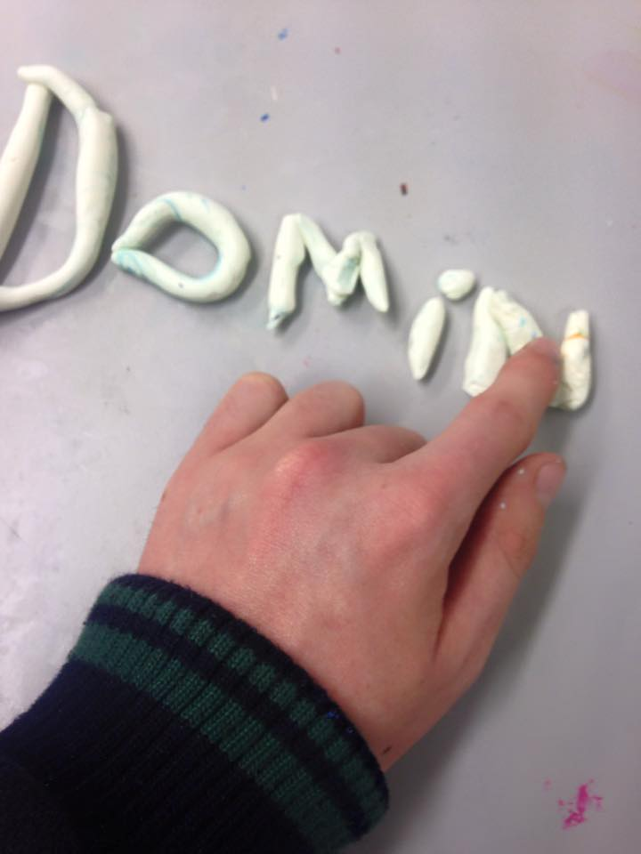

Next Week…
Next week (20th Nov), I can officaly say me and Aaron are ready to make our animation. We will sadly not be in K201, as we will be in the media departments very own ‘green screen room.’ This is the location where our animating will take place. Like everything, I don’t expect to just go into next Friday ready to animate because there needs to be some little prepartion towards this. For instance on Wednesday on my day off, I need to print of a big plain black wallpaper (for the backdrop) ready for when Friday comes around. When we get round to animating,we will kindly ask our tutor for a tripod and camera for us to borrow. If me and Aaron can continue like we did today, next week sounds like another postive day towards the completion of our animation assignment.

’20 November 2015’
Objective for today: (The filming of our animation in the green screen room)
Bad start to our ‘animation’ day
It is Friday again and that only means one thing, animation day! Today me and Aaron, will be hoping to take another huge step towards finishing our assignment come the end of the day.
To kick off proceddings our mood was happy as we knew all our features were created from last week meaning we can crack on with the animating. In the flicker of a moment the feelings all changed, as both I and Aaron realised there are still some more features to create, for instance the ‘player’ title. To help us remember what features we still needed to create we typed it up on a Word document and printed a copy each.

Knowing that we still have a fair bit to do is annyoing and frasturating at the same time. The nightmare of a start got worse, particually for me as I straight away rememberd I had forgot the big plain black wallpaper (for the backdrop.) At this moment in time I just knew it was going to be a long day! To stop anymore woes, me and Aaron headed down to KO21 to eventually get started.
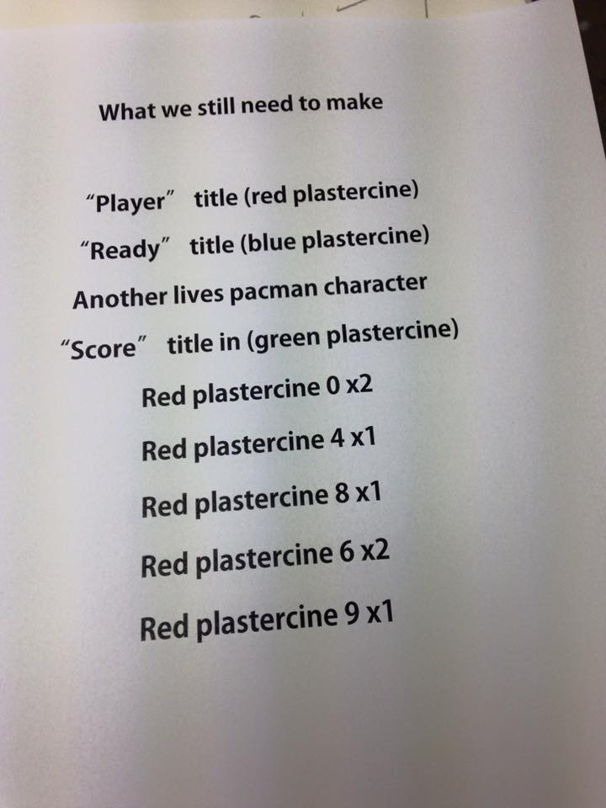
Our features list to help us remember what we still got to make.

Back to the creating
Our nightmares did ease of a little when we got ourself organised effiencetly but it was only a matter of time before the devil came back looming over our shoulder, as this time it was a case of running out of plastercine. Thankfully our tutor lended us some.
After all the issues above in a moment, the engines of both of us eventually got started, which I tell you was a relief for both of us! Just like last week I did one feature whilst Aaron did the other at the same time. I was left with the creation of the numbers for the ‘score’ and Aaron went on to create the more complex of the two, the big chunky letters of the ‘ready’ and ‘player’ titles. Within the time of creating these parts, ideas for a change in plan were brung up by Aaron, as this time instead of a red ‘player’ title we changed it to light blue colour and as for the ‘ready’ title we kept that dark blue. The reason behind this colour scheme is so that they contrast together.
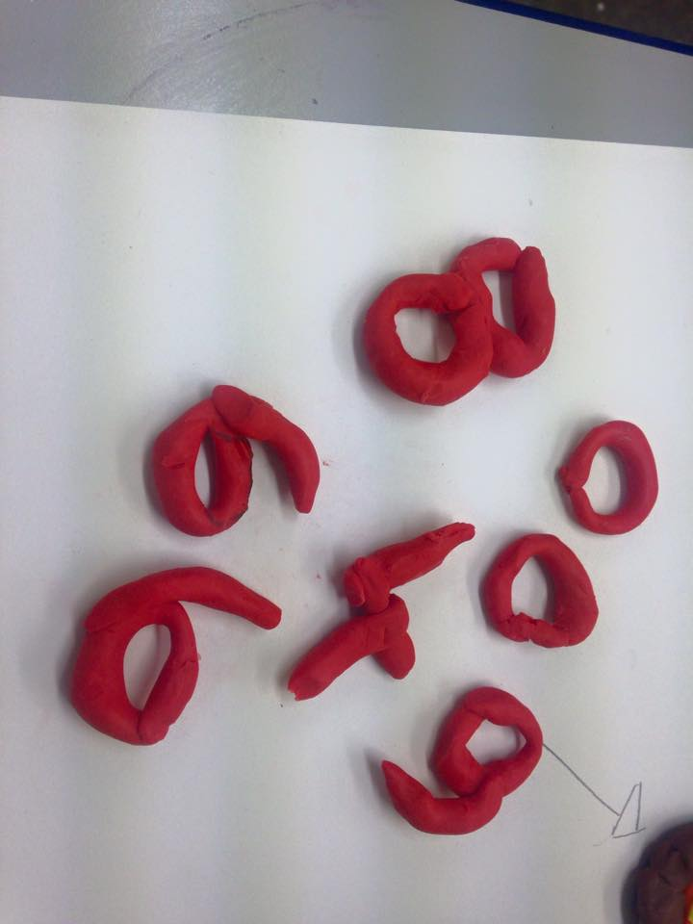
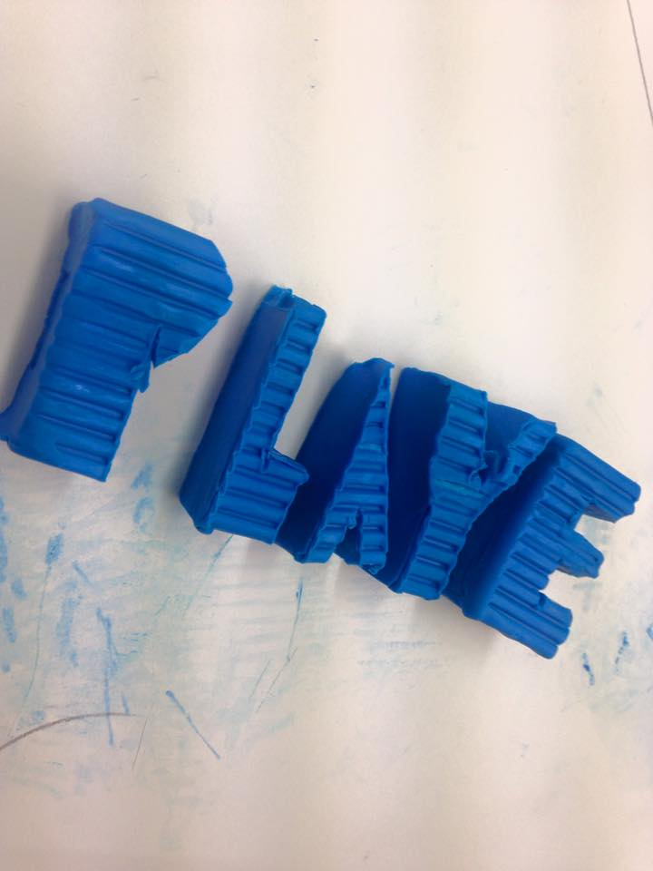

.
The numbers I created for the score.
The ‘player’ title Aaron created out of blue plastercine.

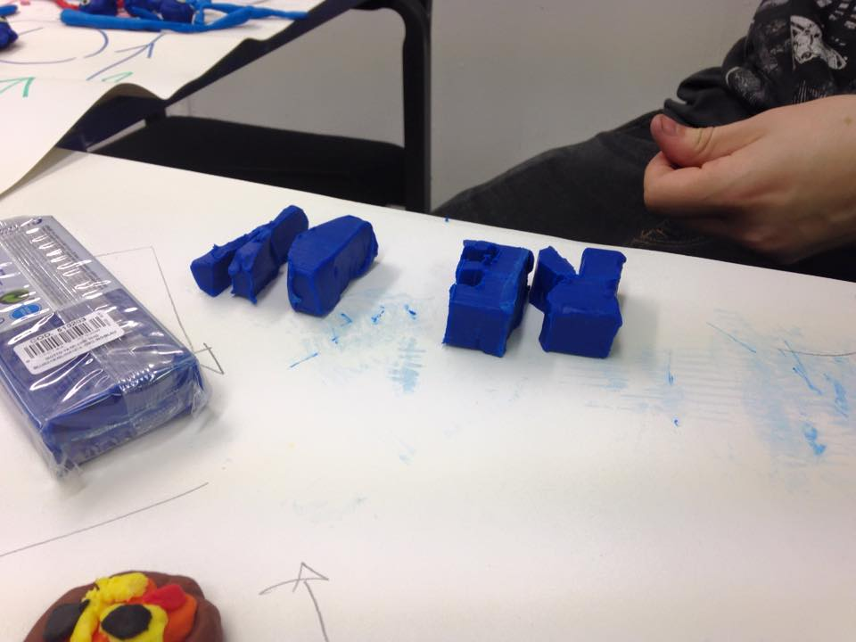

Aaron in the process of creating the ‘ready’ title.

The final feature before break time

Break time was on the horizon and I was so shocked how the time flew by, this only indicates me and Aaron have worked hard for the last hour to recover the ‘shocking’ first half an hour.

Before break we wanted to be at a good stage and to go about this, we wanted to make one last feature each. Easy involvements were down to me and Aaron with the trickier side as seen many times before in this animation project process. Hats for our Pacman to give it that more Domino’s worker feel was my responsibility taking up tasks such as, making dark blue plastercine into chunky looking arch shape hats and simply putting this on top of the Pacmen. As I look at them both closely, I wasn’t able to pick out a Domino’s link, but personally they both look like real French characters. We both laughed at this comment of mien. Back to Aaron’s role, he was left making the ‘score’ title into big chunky grey plastercine letters. This was done with ease like so many times before, as making big chunky letters out of plastercine is the one stand out skill I have picked up from Aaron, as he is so delicate at creating work like this.
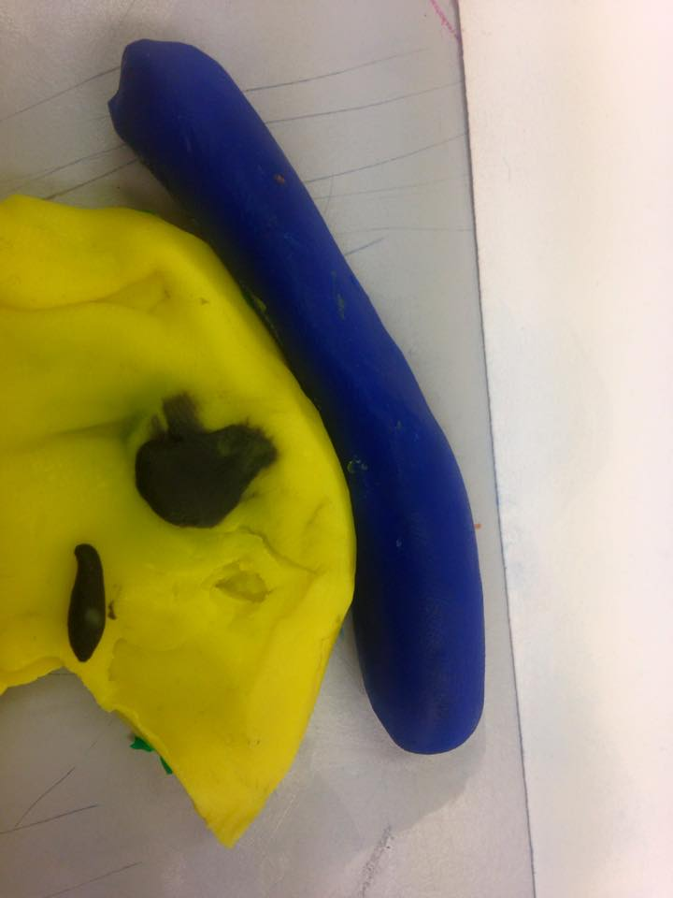

A French character’ a like Pacman figure.

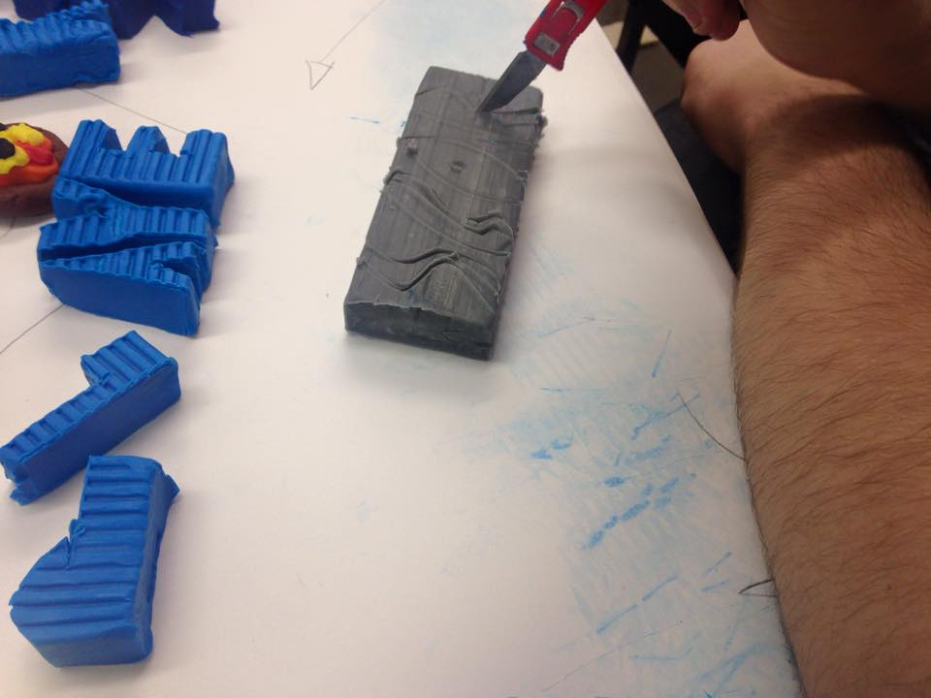

Aaron carefully carving out the letters to make up the ‘score’ title.
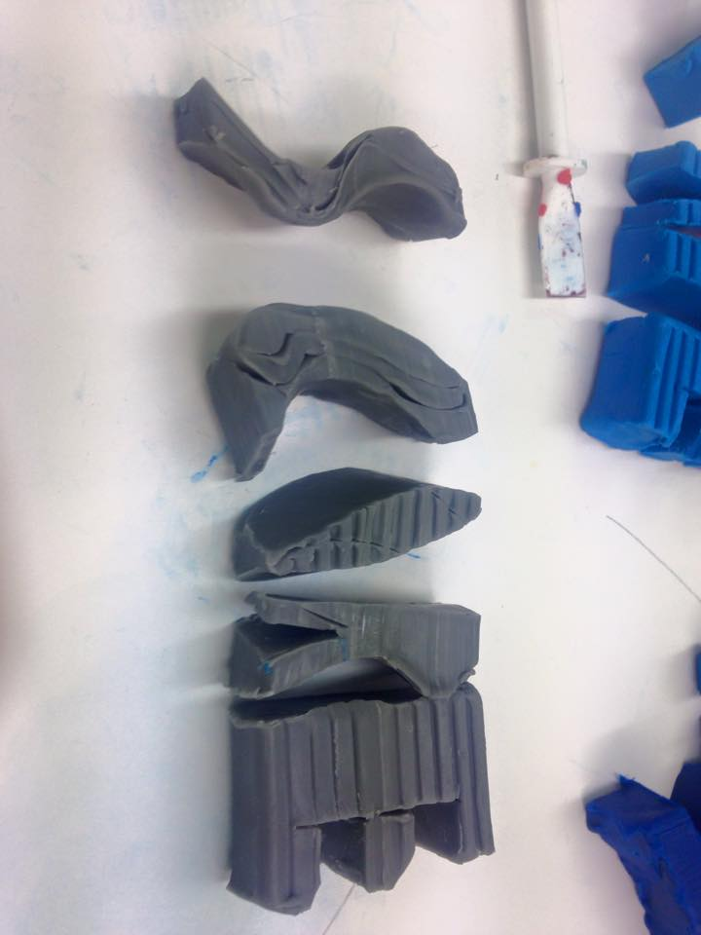

The end product of the ‘score’ title.

Ready for animating!
After wanting to start filming at the start of the lesson, and after a long wait to be at the stage where we so desperately wanted to be, we got there… the animating! Before we started anything we had to come up together a backup resource for the big plain black wallpaper. This needed to be replaced because of my howler of forgetting. A howler from me was quickly solved with a big piece of black sugar paper, getting this resource didn’t involve us going out on another shopping spree as it was provided to us by our tutor.

When we had this and everything else including the camera, we gave our tutor the nod before going up to the ‘green screen room’ as he was willing to help with us set up.

Black sugar paper causes problems.

I and Aaron were hoping for no more problems mostly during the animating process but that was quickly escalated as problems arose once more, even before we started. It was when we were setting up because as we led out the sugar paper and put everything on, we looked through the camera if everything was ok but as you guess it wasn’t! Some features were not in shot meaning I had to run down to K021 to fetch yet another piece, still not everything was in shot! The run up and down was good exercise but honestly it was getting more and more frustrating by the minute. It was third time lucky that we had the right amount of sugar paper meaning we were able to see everything on camera now.

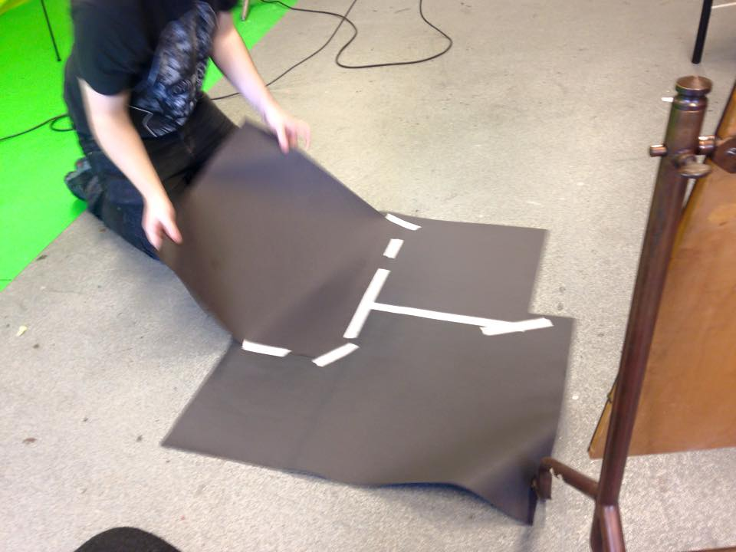
Aaron laying out the third piece of sugar paper before placing our features on for a third time.

Finally recording!
Lunchtime was fast approaching and personally I wanted to get a little bit of animating done so we would have the benefit of an early kick start before going into the afternoon period. This couldn’t have gone any better, I and Aaron working well as a team once more, Aaron took the snaps and I moved the features. Just before lunch arrived we flicked through on the camera the footage and so far so good I must say, even our tutor was impressed. There was no point in moving anything, so we just left it on the floor. When we go into the afternoon period it is just simply a continuation process.
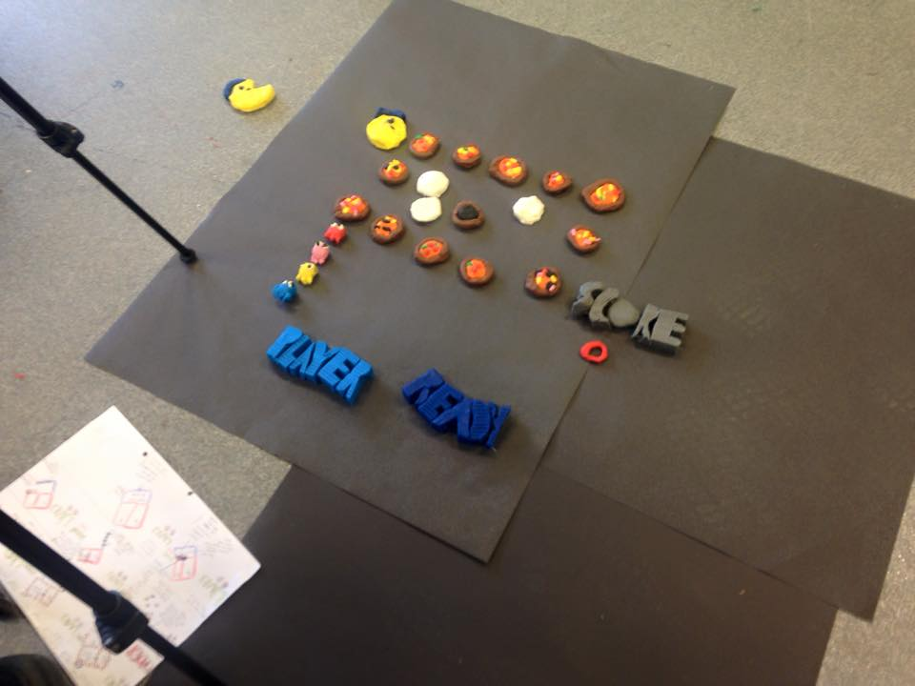

Everything all in place before we begin!

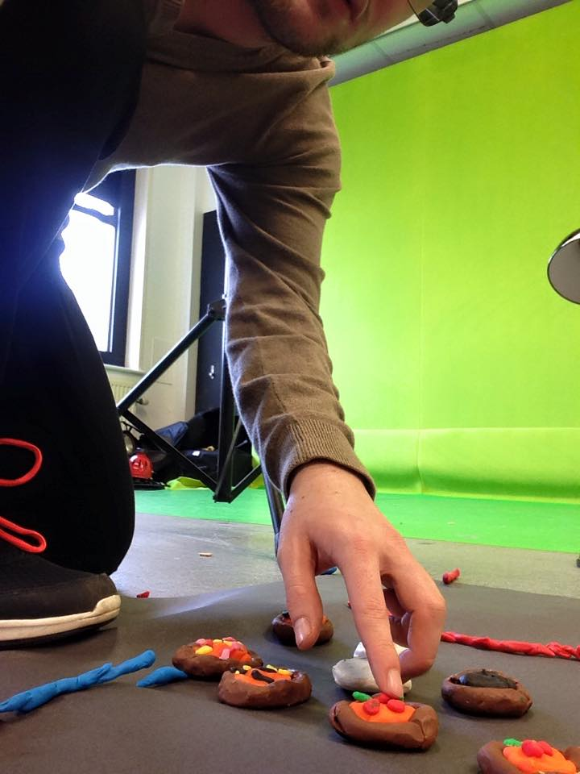

Here is me as I take up my job role of moving the features.

The continuation after lunch.

After lunch it was a mixed bag of an afternoon, Aaron went off 90% of the time to other groups proving his lose in motivation, resulting in me to pick up the pieces and carry on. From what I achieved independently I am happy but at the same time disappointed in Aaron’s lack of contribution. My job was simple, continue on what I did in the last part of the morning as well as taking up Aaron’s job role, so in a way I was multitasking. Before all this I had to run down to Owain to get hold of another battery as this battery I was using ran out due to me leaving the camera on over lunch.

When 14:45 arrived, I look of how far I have come this afternoon, it may not look much but with our animating admitally it takes up a very slow process. When referring to the camera footage I still got the impression I didn’t do much, but I know it was a good point to finish at for today. During the time of me flickering through all my photos I deleted the not so good ones, meaning it saves me a job when I edit. My tutor said to me to conclude, just to leave it all out as we will be coming back to this next Friday and hopefully nobody will ruin and move anything.

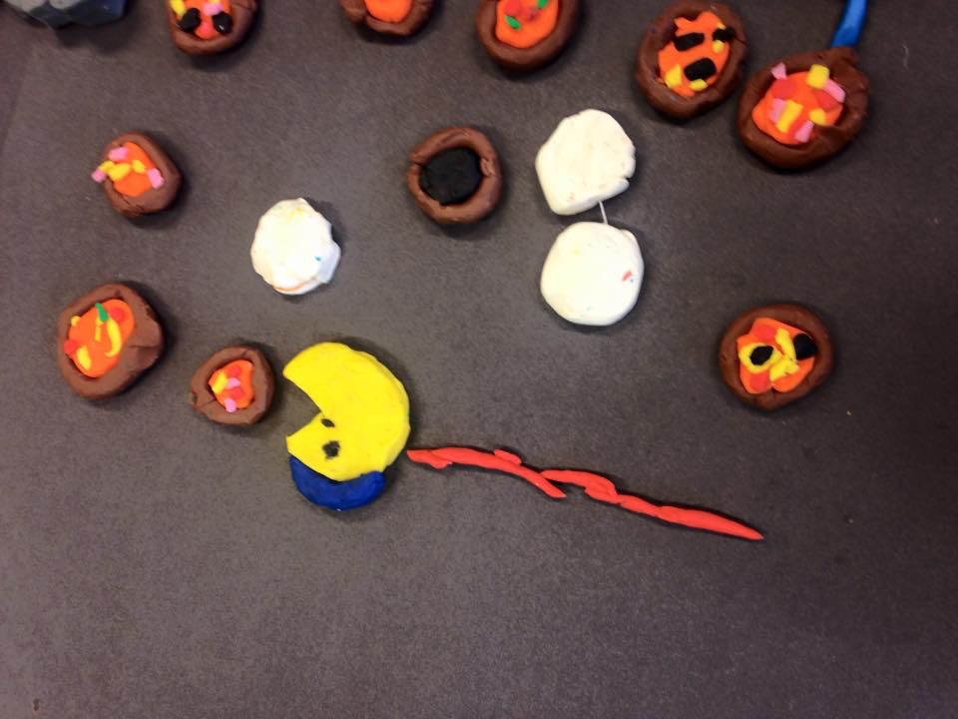
The stage I am at currently.

Next week…
Next week is a new week and I just hope it brings brighter sides compared to this week’s nightmare show, as well as all this I hope by next week my partner Aaron picks up his motivation because I am making this clear “we are not a one man team!” I pinpoint the not finishing of animating today to Aaron’s not participation resulting in next week more animating. If I could make one wish, I would wish for us to link back up together and produce some good team work like I know we can

to get this animating out the way meaning the following week (4th Dec) we have a whole lesson dedicated to editing.

’27 November 2015’

Objective for today (continuing and finishing filming stage)

Picking up from last week

This week has been a very long tiring week for me but I admit this now I am so happy my favourite day has arrived! (Animation day). With some animating on the agenda last week, it was important this week for me and Aaron to pick up upon this and hopefully complete the animating stage come 15:15. We finished up in the ‘green screen room’ last week and this week it was a case of starting there. When we arrived we straight away found some of our work had been messed up a little, but not to worry as we expected this as we knew other groups in the media department have used this room throughout the week. To recover this mess it was a case of me putting everything back where it was originally whilst Aaron set up our camera and tripod for the day.

Early stages of week three.
Before we began anything relating to animating we had a quick glimpse of what footage we had so far and so far so good! After looking at the clock it was 9:45 and we were ready, to kick start once more!

Reflecting on the footage so far and looking at our current stage, I and Aaron were ever so close to finishing the animating stage. To give you an idea in a nutshell, all that remained was three pizzas which were led ready for the Pacman to eat, whereas the ghosts, are on the approach to the final straight. Aaron’s motivation had picked up immensely from last week which is pleasing for us as a team, this resulted in us getting more done which gave me positive signs for the day ahead!

The closing stages of filming
Like so many times before in this process of completing this assignment, we produced further more half and half team displays. This time it came from I did half of taking the shots, Aaron did the other half. It doesn’t end there as another came from us sharing the part of moving the last few features. With quick delicate speed, just after the break interval the logo was accomplished! This may sound overwhelming news for us both, but along the way it wasn’t all happy, as we did have a little hiccup to intend with. A ‘special’ thanks to our tutor for pointing this out to us. The hiccup was the number ‘9’ for the ‘score’, as it appeared the wrong way round for at least 10 minutes of footage without us even realising. This was a huge ‘school boy error’ for me as it was my turn in moving the features. Personally I should have known it wasn’t right, it was just a moment I wasn’t thinking straight. This matter got worse as I couldn’t even get it the right way round so that meant superhero, Matt saved my woes! Now we can officially say…. WE HAVE FINISHED!! But………………..

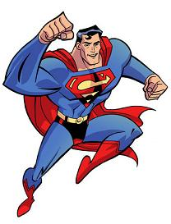

The extra touch
Just as we thought we had finished, we had but we wanted to add a ‘special’ touch to proceedings. This luckily came hand in hand as we had a moment where we nearly forgot a key element to the logo. We had forgot to add in the lettering of ‘Domino’s Pizza’, to be fair with you when we had the whole logo finished I was left thinking, the logo is looking quite blank with no title. For the benefit of more shots, we thought it would be best to take a shot each time we put in a letter, until we made the lettering up. All this above is not the extra touch because where the special touch comes in, is when Aaron went on to make a star symbol feature to give the lettering that stand out factor.

Other ideas to conclude animating

Throughout this whole process I and Aaron have been launching ourselves into new ideas which have been trial and error moments before turning into successes! For sure this is the last change of plan. Aaron suggested, to give the animation that brighter side to it, he thought it would be best the Pacman should actually win the game compared to the original where he gets killed by the ‘evil’ looking dark blue ghost. After discussions with our tutor he agreed and was happy with this change.

Time to start editing
Like ever in these sessions they fly by. With lunch on the horizon yet again, we made a little start upon the next stage (editing). Aaron got all the footage of the camera for him to put on his ‘Temporary Storage’ area. Altogether we had ‘152’ photos (narrowing to 133) and other big files attached such as Aaron’s video blogs so this meant it took a long time to transfer over. Before he got bored, he came and joined me in completing our blogs for the day just before lunch.

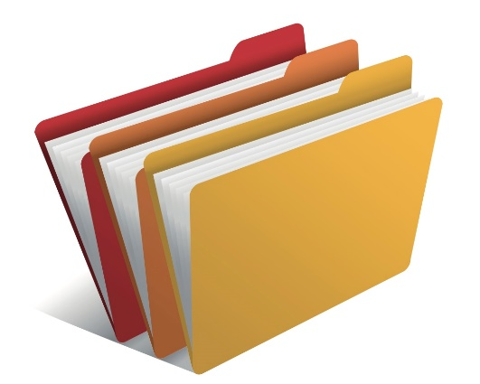

The start of a new stage…

It was after lunch and we were ready to edit. Personally I wasn’t expecting to be at this stage today so this has made me stress free with happy thoughts. With early beginnings it was all about my turn in importing all the footage (photo stills) to our editing software ‘Adobe Premiere CC 2015’. When this was all imported, we both went off to ‘switch off’ mode for a few minutes but as soon as we turned our backs to face the computer once more, red warning stroke!!!!

Thankfully our tutor stated “it is not a serious matter” it was just a case of ‘locating all our footage, as no media was found.’ I left this rescue misson to my tutor as at this moment in time I was scared of crashing the computer. Computer saved resulted in us being able to continue. So once more we had all our footage on the left hand side of the screen, but all in the wrong order so this meant it was a case of us sorting them out as well as setting them to a suitable time duration. With the shots there was times where me and Aaron both agreed to make some shots have a longer length where the others have smaller lengths. This was all for the benefit of a better end product and to make sure the video has a longer duration, when staying with the time requirements subject, 20 seconds is the bench mark but me and Aaron had to come to face with our video didn’t meet that requirement (our duration 12 seconds) With a spark in the mind by Aaron in the flicker of a moment, as a perfect thought to get to a close 20 seconds we will be adding in the Domino’s ending which we felt inspired by in the new adverts. With some ‘A* maths skills from us both we calculated it would take us up to 17 seconds, still not enough time, but to push those seconds up we may need to try and find a solution to bulk it out next week when we have all day.

Next Week…

Next week our tutor has given us all a strict deadline to get all our animating and editing done by the end of next week, if not to be done in our spare time! This may be harsh to us all but there isn’t much effect from this to me and Aaron as we are ahead of the game already. The thought of having all day next week leaves me thinking next Friday will be a pretty chilled morning/afternoon spent adding in sound effects and touching upon the final editing parts. Come the end of the day we are hoping to have the achievement of having our animation looking smooth and uploaded to YouTube.

Simply to reflect today, I am so happy me and Aaron have got our animating accomplished! This results in no more worries with this and results us as ever being ready to move on and carrying on to the next part. (Editing)

‘4 December 2015’
Objective for today: (The making of all the features such as the pizzas)

The beginning of the end
With a final day on the horizon I have set myself a ‘SMART target’ to achieve to be done everything and uploaded come 15:15. Before we could do anymore editing, it was a case of trigging the ‘rendering’ button (enter key on the keyboard.) This meant all our footage became rendered. I got this done just before I headed down to our very own LRC (learning resource centre) to pick up myself some headphones enabling me to hear the sounds.

Sounds
Back to business on the computer, after everything was rendered it was the time to add in some sound effects to proceedings, sounds included a copyright free ‘Pacman’ theme all to last throughout the whole animation. Sorting sounds out were no problems, we haven’t heard that phrase much throughout the different stages.

The extra touches to the editing

Extra touches to the editing came into action as soon as sounds was swept aside so easily. With everything going well so far today, we went onto proceed with last week’s way of pushing seconds up. We will be adding in the Domino’s ending. The process was simple, download the video to an MP4 format, put in our temp store and throw it in at the end. Obviously we didn’t just throw the whole advert in, we trimmed it down to the relevant parts. The same process was repeated when we came onto another solution to bolster up the seconds as still the animation was not long enough. After discussions with my tutor and Aaron we thought an intro to the animation will seal ‘the icing on the cake’. The way in which we went about this is to go make the ‘Bandai Namco’s logo animation’ into again an MP4 format before placing at the start. Just like before, I trimmed this down to the necessary parts.

Breakthrough

Breakthrough!!! Once rendered again, the editing and our group had a massive sigh of relief!!! I had 17 seconds! This sounded so overwhelming to hear some finally positive news and the fact that I got this done just before lunch made our hour break that extra bit sweeter.

The final stride

After watching back my animation five to six times by analysing and stopping little parts along the way my tutor came in to help me make my product that extra bit better. The edit I just got done became my ‘draft’ version, but the one we both worked on was the ‘final’ version (making a 2nd copy). Tasks such as changing the scale needed to be touched upon to get the animation looking fine. At this current moment we are in touching distance of the finish line but one last part stood in the way which was not a barrier by any sense. Like anything in film editing when doing parts to it, parts will move around and make the footage look all over the place. I thank my tutor to step in to carry on helping me locate everything back to its rightful place.

The uploading has finally arrived
When we hit the export button my feelings were bubbling up to become very excited and this became reality when the video was officially published to ‘Wiltshire College’s TV and Film’ YouTube channel.

The little concern

Before I end my blog, during my time of editing I came across some pixilation concerns. It came when I put the Domino’s ending and the ‘Bandai Namco’s logo animation’ they all came out a little blurred so that meant they could only be pixilated. My worries got to the point of asking my tutor if everthing was ok, but all it was is “this is normal and it will be back to normal come being live on YouTube”.

Conclusion

After five weeks of hard dedicated work from both me and Aaron we have FINISHED!!!! I feel like running outside and run all the way round Trowbridge, as in this current moment in time I feel so, so happy. Owain was happy, I was happy, Aaron was happy so it was all smiles all round. The beaming smile on my face grew bigger when I knew we were the first official group to have our video finished and uploaded online.

